**Project 1 - Octagonal Prism**

Screenshot:

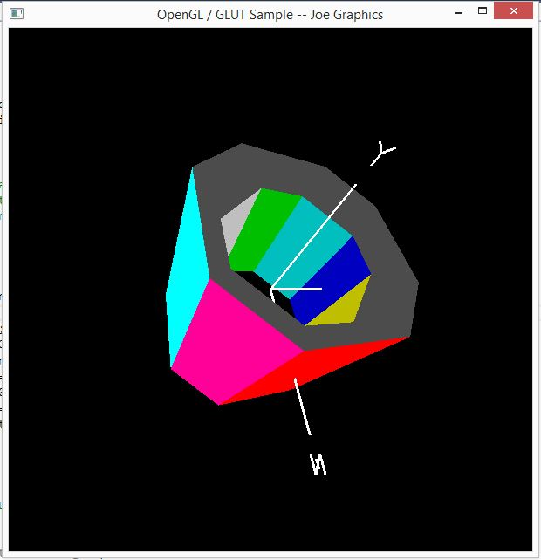

Video Link: <https://media.oregonstate.edu/media/t/0_n0suxd89>

I forgot to mention in the video, but as you can see from my screencap, I have more than 5 different colors.

Thanks, and have a great day!